**Deutsch–Jozsa Algorithm**

The **Deutsch–Jozsa algorithm** is a [deterministic](https://en.wikipedia.org/wiki/Deterministic_algorithm) [quantum algorithm](https://en.wikipedia.org/wiki/Quantum_algorithm) proposed by [David Deutsch](https://en.wikipedia.org/wiki/David_Deutsch) and [Richard Jozsa](https://en.wikipedia.org/wiki/Richard_Jozsa) in 1992 with improvements by [Richard Cleve](https://en.wikipedia.org/wiki/Richard_Cleve), [Artur Ekert](https://en.wikipedia.org/wiki/Artur_Ekert" \o "Artur Ekert), Chiara Macchiavello, and [Michele Mosca](https://en.wikipedia.org/wiki/Michele_Mosca) in 1998. Although of little current practical use, it is one of the first examples of a quantum algorithm that is [exponentially faster](https://en.wikipedia.org/wiki/Time_complexity) than any possible deterministic classical algorithm.

The Deutsch-Jozsa algorithm, first introduced was the first example of a quantum algorithm that performs better than the best classical algorithm. It showed that there can be advantages to using a quantum computer as a computational tool for a specific problem.

**Deutsch-Jozsa problem**

Given a hiden boolean function f which takes as input a string of bits and returns either 0 or 1:



The property of the given Boolean function is that it is guaranteed to either be balanced or constant. A constant function returns all 0's or all 1's for any input, while a balanced function returns 0's for exactly half of all inputs and 1's for the other half. Our task is to determine whether the given function is balanced or constant.

**The Classical Solution**

Classically, in the best case, two queries to the oracle can determine if the hidden Boolean function, , is balanced: e.g. if we get both f(0,0,0,...)🡪0 and f(1,1,1,...)🡪1 then we know the function is balanced as we have obtained the two different outputs.

In the worst case, if we continue to see the same output for each input we try, we will have to check exactly half of all possible inputs plus one in order to be certain that f(x) is constant. Since the total number of possible inputs is 2^n this implies that we need 2^(n-1) +1trial inputs to be certain that f(x) is constant in the worst case.

**Quantum Solution**

Using a quantum computer, we can solve this problem with 100% confidence after only one call to the function f(x), provided we have the function f  implemented as a quantum oracle, which maps the state

 to 

where  is addition modulo . Below is the generic circuit for the Deutsch-Jozsa algorithm.

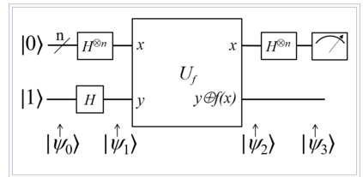

**Steps of the algorithm:**

1)Prepare two quantum registers. The first is an n-qubit register initialized to |0> , and the second is a one-qubit register initialized to|1>



2)Apply a Hadamard gate to each qubit

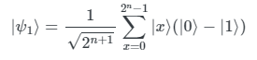

3)Apply the quantum oracle

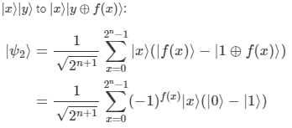

4)At this point the second single qubit register may be ignored. Apply a Hadamard gate to each qubit in the first register

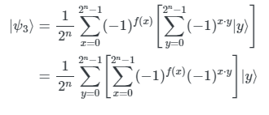\

5)Measure the first register.

 if and only if we measure |0⟩ and �(0)⊕�(1)=1  if and only if we measure |1⟩. So with certainty we know whether �(�)f(x) is constant or balanced.